ECONOMY & POLITICS

1821 Greek National Revolution bicentennial

200 years of Greco-Serbian shared vision for freedom
7 DECEMBER 2020,
ALEKSANDRA PEĆINAR
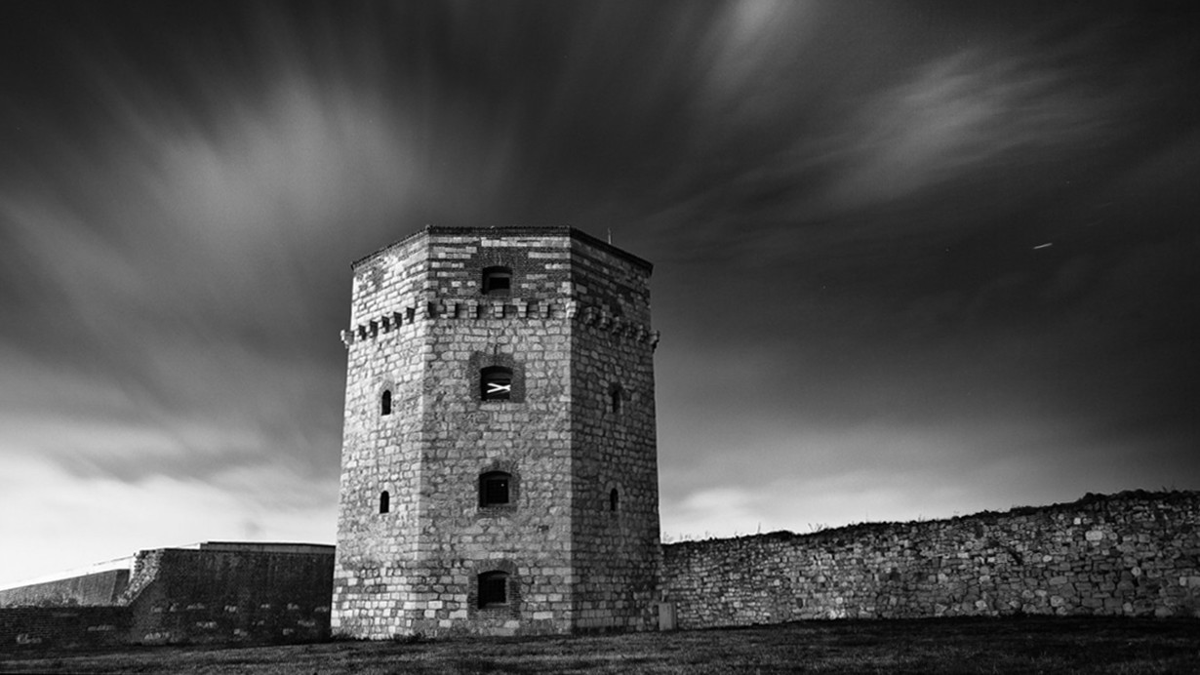
The Nebojsa Tower in Belgrade
March 25, 1821, symbolizing the beginning of the uprising of the Greek nation "to shake off the long-standing Turkish yoke", represents the most important landmark in Modern Greek history. Meaning the first organized action which aimed at a coordinated uprising of the Greeks and other enslaved Christian nations of the Ottoman Empire, the Revolution was crowned with success and laid the foundations of the New Greek State. Nowadays, the Greek National Revolution as a historical milestone with international implications highlights a variety of strategies, military tactics, political processes, economic and cultural aspects and psychological factors. Witnessing the diachronic and international importance of the Revolution and in view of its bicentennial anniversary, the Greek Presidential decree has been issued regarding the Constitution and operation of the “Greece 2021” Committee, which shall come under the Prime Minister and have its own legal personality to fulfill its purpose.
However, apart from its international character this unprecedented event of Modern history had catalyzed in decisive manner bilateral relations between two friendly orthodox Balkan countries, Greece and Serbia with a long tradition of close friendships. Connected by a long history of joint struggles for freedom, they have many times demonstrated their common goals and spiritual proximity during the past. Unambiguously, the upcoming 2021 commemorations offers an opportunity to reflect, but also to draw useful conclusions, because this anniversary is not just a historical a milestone. It is also for national thinking and strategic planning for the future.

History as an inspiration for future
The expansionist impulse of the Turks towards Central Europe had been stopped at the beginning of the 18th century and the prevailing peace resulted in the development of a Greek migration stream to the Balkans. The trade movements of the peoples of Macedonia, Epirus and Thessaly in the northern Balkans that followed were recorded by historiography as an important aspect of the process of economic development and the national formation of Christian populations of the Balkans. Especially Serbia, the country adjacent to commercial centers, had been playing an important role in Greek export trade, serving since the Passarowitz Peace Treaty (1718) not only as a bridge for passing traders but also as a trading destination for Greek goods. The name Greek ended up being synonymous with the word merchant, while many of them also settled in Belgrade and Semlin (Zemun). In 1823, out of a total of about 9,000 inhabitants of Semlin, 1,000 were Greeks.
The trade in the Balkan regions had created a similar intellectual mobility and the circulation of ideas starting from 1789 created expectations among enslaved peoples of the Balkans. The ground for a common action had been prepared by the Greek intellectual and revolutionary Rigas Feraios (1757-1798), inspired by the French Revolution, who envisioned a common revolution of all the Balkan nations against the Ottoman Empire and the formation of a Balkan federation. He was finally arrested by the Austrian police in Trieste and extradited to the Turks in Belgrade. Nevertheless, his tragic end raised him to the level of the first martyr of the liberation struggle of Hellenism.
As early as the beginning of the 19th century, as bearers of the ideas of the Enlightenment and Nationalism, Greeks and Serbs played an important role in the political developments of the Balkans. The First Serbian Uprising and the secret preparations for a Greek revolution coincided. Consequently, the first effective challenge to Ottoman rule began on the initiative of Serbs and Greeks almost simultaneously. The news of the Serbian revolt of 1804 were received with great joy by the Greeks, who viewed it as a paradigm for a Greek national revolution. Several distinguished Serbs had been accepted as members ("brothers") in the Filiki Eteria, the secret organization that prepared the Greek Revolution, despite officially only enlisting ethnic Greeks. Symbolic of Greek-Serbian friendship was the blood brotherhood between Greek "armatolos" (Christian Greek irregular soldier) Giorgakis Olympios and Serbian rebel leader Karađorđe; On the other hand, many eminent Greeks in Wallachia and Russia, politicians, merchants etc. assisted the Serbian Revolution in many ways. The great resonance of the Serbian uprisings in the area of Greek intellectuals and revolutionaries resulted in their material and moral support. Corresponding was the response of the Serbs with a significant contribution to the Greek Revolution. The political and military leader of the revolution, Alexandros Ypsilantis, apart from Greeks and other ethnicities, had a number of Serb fighters under his command, Captains Milenko Stojković, Petar Dobrnjac, Hadži-Prodan, Mladen Milovanović and archimandrite "Servos".
The Serbian uprisings and the Greek Revolution were the forerunners of the modern era in the Balkans, transforming the two peoples, as creators of the first nation-states, into key players in reshaping the political map in Southeastern Europe and the Near East. ¹

Serbia and Greece as the stability factors in the past and in the Balkans perspective
The Balkans with their high geopolitical importance have always been a field of competition and conflict between the Great Powers, Regional Powers and local transnational disputes. The current fluid developments in the Balkans are not an autonomous and isolated event but are linked to instability in the wider Middle East, Eastern Europe, Eastern Mediterranean and North Africa. However, the facts in the Balkans nowadays are undoubtedly clearly differentiated from those of the past and not only from the beginning of the 19th century. Despite the transformation of the Balkan political map and the creation of the current Balkan mosaic, assessing current data based on quantitative and qualitative characteristics of the two countries and, positive conclusions are reached on the possibility of establishing credible cooperation within an institutional framework that would methodologically promote peace and co-operation across the Balkan region.
The bilateral relations between the Hellenic Republic and the Republic of Serbia are based on strong foundations that were forged within the framework of common historical, religious, cultural and social ties, centuries ago. Apart from Rigas Feraios, the great visionary who first sowed the seeds of a common Balkan perspective and was the first to show the way to peace and cooperation in the Balkans, we should not also forget the close contacts and initiatives that the leaders of the two countries made lately. The common interest of Serbia and Greece remains the same -to safeguard the stability, security and prosperity of Southeast Europe. The recently (2019) established strategic partnership of Serbia and Greece could potentially represent the beginnings of "new epoch" of enhanced cooperation within the Balkans. This is a very important document highlighting not only the excellent state of bilateral relations but also the potential to expand them in all fields; especially in trade and new technologies, which provide for new opportunities. ² It should be noted, however, that many Greek companies have already recognized Serbian investment potential and have decided to locate their operations, but the two countries have not yet explored the opportunities and complementarities in many sectors, while bilateral cooperation is not equally reflected in commercial sector. ³
Cooperation between Greece and Serbia is very important for stability in the Balkans and in the wider region. According to certain estimations Greece with bilateral relations to the south with Israel, Jordan, Egypt, the United Arab Emirates and of course with the trilateral relations with these countries and with Cyprus, but also to the north with Bulgaria and Romania, could develop with Serbia an axis of stability, peace and progress in the Balkans and Europe and bring stability and peace in region. Moreover, Serbia could represent an important intermediate country for Greece to establish a healthy geopolitical relationship with Moscow, Beijing, the Arab states, Iran, Paris, etc. and to create a strong geopolitical complex of high potential.
At a time when Europe, at least in the foreseeable future, is not announcing any significant progress in this area, the complementary characteristics of Greece and Serbia may be the basis for the security and prosperity of tomorrow's Balkans. The upcoming celebration of the 200 years since the outbreak of the Greek Revolution of 1821 and the War of Independence will be a key historical event: it is both an occasion to recognize the struggles and sacrifices of two peoples while it also requires us to think on the present-day position of Serbia and Greece and their future. The key step in establishing long-term cooperation is not only institutional coordination of foreign policy of the two friendly countries, but proposals for creative cooperation for solutions based on ideological and cultural denominators of the past and nurturing socio-economic responsibility in order to create a broader basis of institutional support.

Notes
¹ A. Pecinar- G Doudoumis, Greece and Serbia as the Stability Factors in past and in the Balkan`s Perspective, Athens 2020.
² Εκθεση 2019-2020 Γραφείου Οικονομικών και Εμπορικών Υποθέσεων Βελιγραδίου για την Οικονομία στη Σερβία και την Ανάπτυξη των Οικονομικών και Εμπορικών Σχέσεων Ελλάδας και Σερβίας, Οκτώβριος 2020.
³ Hellenic Business Association of Serbia.

Aleksandra Pećinar
Historian. United Nations mandated-University for Peace –European Center for Peace and Development, Serbia -Adviser for Geostrategic Issues in South-East Europe. National Research Foundation "Eleftherios K. Venizelos", Greece - Official Representative for Serbia Author of "Diplomatic and allied relations of Serbia and Greece (1912-1918)", Ministry of Defense of Republic of Serbia..
Author profile
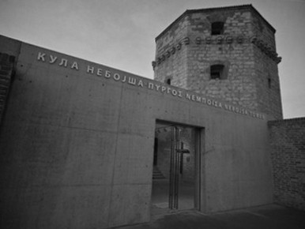
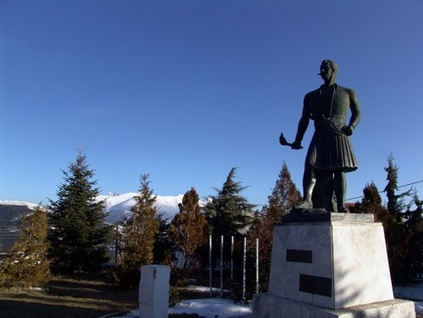
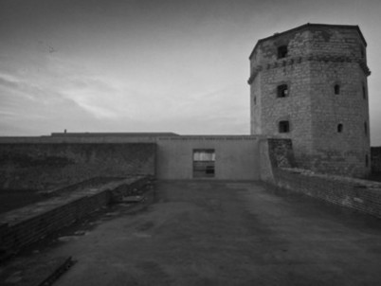
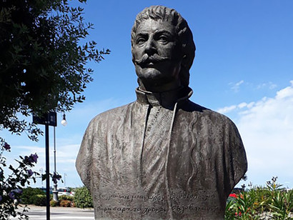
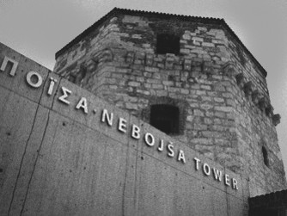
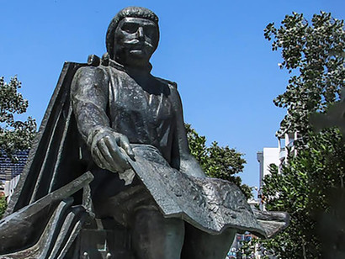
- The Nebojsa Tower in Belgrade
- Giorgakis Olympios
- The Nebojsa Tower in Belgrade
- Rigas Feraios
- The Nebojsa Tower in Belgrade
- Rigas Feraios

